Lab 6.5 Liveness & Readiness Probes

1. Create a Dry run yaml using this command:

**kubectl create deploy livenessprobe --image busybox -o yaml --dry-run > livenessprobe.yml**

1. Update the YAML file to be as shown:

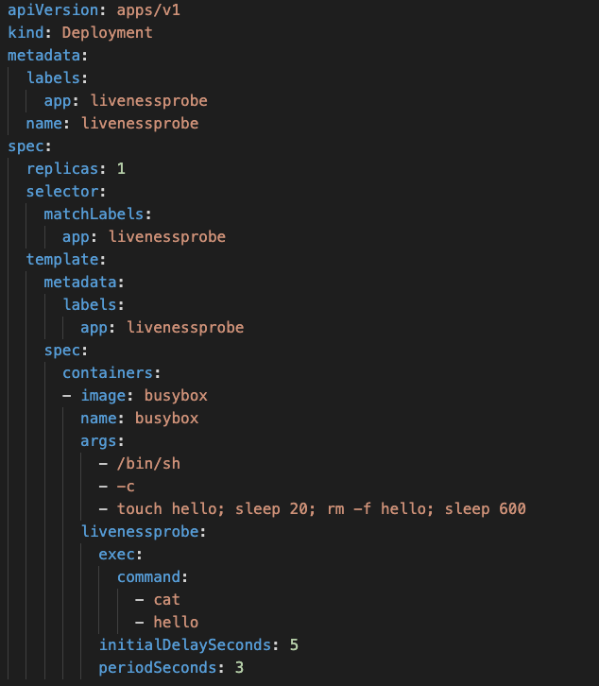

1. Create the Pod

**kubectl create -f livenessprobe.yml**

1. Validate if everything is working well.

**kubectl get all**

1. Check the Events and notice the Unhealthy message

**Kubectl get events**

1. Check the number of restarts

**kubectl get pods**

1. Create a readinessProbe.yml

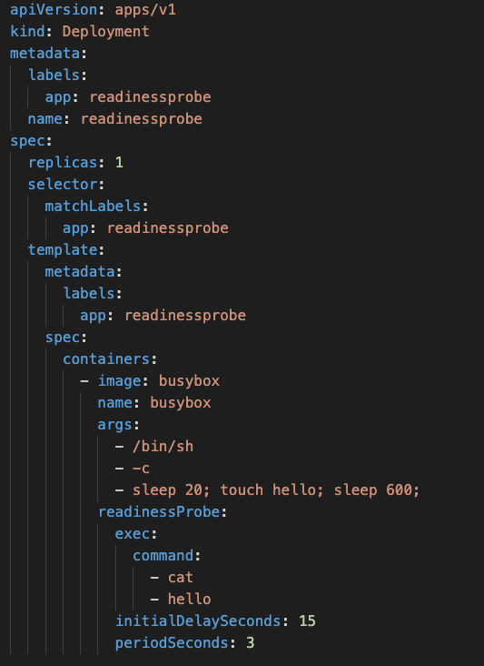

1. Create the Pod

**kubectl create -f readiness-probe.yml**

1. Check the Ready state of the Pod. It would not be ready for up to 15s

**kubectl get all**

1. Delete both the Pods